# INTRODUCTION

I completed my Bachelor of Technology from University of Delhi in 2020 with a major in information technology and a minor in business innovation management. Right after that, I enrolled in Master of Predictive Analytics course at Curtin University. I do not have major work experiences to count on for a self-analysis. However, I have had opportunities to work individually, to work in teams, and to lead teams for various projects during my undergraduate and graduate studies.

I am a budding data analyst by training. It is a developing field with promising business applications. I aspire to be on the forefront of the data revolution and be on an executive position of a prominent firm within next ten years. I am aware that development of technological skill is not enough to realise this goal. I will be leading and managing teams. More importantly, I will be working in teams. Therefore, it is imperative to evolve my managerial skills.

Aristotle famously said that the starting point of all the wisdom is knowledge of self. It is principle to reflect on past to develop one’s best self. However, analysing any human being – even self, is a strenuous task due to complexity of human condition. Luckily we are living in modern era of management. In this era, eminent management thinkers and researchers have developed scientific tools and methods to help one in analysing specific aspects of themselves with varying degree of success. Surprisingly, most of these tools are objectively simple. One can administer them on their own and draw cardinal insights. I will be using few such existing tools to refine my self-awareness about individual behaviour and processes, team processes, and organisational processes.

This assessment would serve as my first endeavour in a series of upcoming endeavours to learn about self and bring out my best-self.

# INDIVIDUAL BEHAVIOUR AND PROCESSES

## MACH-IV test of Machiavellianism

Christie (2013) define Machiavellianism as a trait where an individual displays willingness to cut corners and use manipulative techniques to achieve personal goals. The trait is named after 15th century philosopher Niccolò Machiavelli. It is one of the three dark triads as conceptualised by Paulhus and Williams (2002).

MACH-IV is a 20-question test developed by Christie and Geis (1970). It can be self-administered through open-source psychometric project. Appel et al. (2019) concludes that senior executives tend to display Machiavellianism four times more than common populace. There has been increasing academic support to the notion that people with Machiavellianism are more likely to rise through corporate ranks (Furnham et al. 2013). I chose to take MACH-IV test due to this expansion in academic evidence, my goal of being on an executive position, and my general curiosity to walk on unconventional paths. Another reason is that exploring the dark side of individual behaviour provides benefits of better self-acceptance and decline in approval seeking tendencies.

I got a score of 73/100. According to the snap in appendix-1, 73 lies in the half with higher level of Machiavellianism. However, it is not sharply high. The test results are in par with my pre-test expectation. The reason is that my individual beliefs align with what are generally considered as Machiavellian notions. I believe that organisational justice may not be present everywhere. I also believe that in absence of organisational justice, neither complying or complaining are reasonable strategy. One has to make their own way and at times it might be required to cut few corners to achieve the end goal.

Taking this test made me more accepting of my individual behaviour. Higher level of Machiavellianism come with workplace challenges. According to Furtner et al. (2017), people with high MACH-IV score are reckoned to be uncaring and may engage in workplace bullying. I am imperative that after taking this test and identifying challenges associated with Machiavellian personality, I will be extra cautious in workplace towards these challenges. I am uncertain if I can reduce my level of Machiavellianism. Therefore, my future strategy is based on managing it. It is not alarmingly high to start with. My focus would be on using advantages associated with this trait while keeping a firm check on its challenges.

## Motivational Style (BIS/BAS) Scale

Jeffery Gray theorised biopsychological theory of personality (Matthews & Gilliland 1999). According to the theory, there are two brain-based systems which are responsible in determining how individuals react to varying situations. These systems are, behavioural inhibition system (BIS) and behavioural activation system (BAS). BIS determines how a person reacts to negative outcomes. BAS determines a person’s reaction to rewards. BIS and BAS systems generally work in inverse of each-other. People with a strong BAS would avoid those tasks where they perceive high probability of negative outcomes. It is hard for them to accept negative outcomes. People with a strong BIS would actively engage in activities where they perceive probability of positive outcomes. There are various scales to determine strength of BAS and BIS. I have used BIS/BAS scale developed by The Science of Behaviour Change (SOBC) program. This scale has 24 questions.

I chose this test as it is based on a theory that has neuropsychological roots. I wanted to take a test that is more appropriate indicator of a person’s biological design. My BAS score as per the test is 19 and my BIS score is 20. According to SOBC program, my BAS score is average and my BIS score is on the higher-end. It means that I am not more likely to get affected by negative outcomes than an average person and I am more likely to feel excited an motivated from positive outcomes than an average person.

Before the test, I had no expectation about the result. I was oblivious of where my BAS and BIS stands as compared to general populace. However, I feel the results are justified as I have observed that I tend to take more risks than my fellow students. An example being, while most in my circle decided to defer their plans to study abroad after outbreak of COVID-19, I decided to go ahead with online studies as I am able to see positives and opportunities (savings in rent and food) here as well.

As someone with average BIS and above-average BAS, I am susceptible to take spur of the moment decisions with high risk (O’Connor et al. 2009). A good thing is that results of this test made me aware of this issue that I might face. A thing that I would do differently in my first professional workplace is that I will implement an artificial BIS system. I will develop personal rules that I will use to penalise decisions that I might be finding alluring in spur of the moment due to my high BAS.

# Team Processes

## DISC Assessment Test

DISC stands for dominance, inducement, submission, and compliance. Marston in 1926 theorised that people interact with external environment using one of these four methods (Dillenburger & Keenan 2005). Various DISC assessments have been made based on Marston’s theory. I used DISC Assessment Test developed by Open-Source Psychometric Project.

I chose to take this test due to its popularity in hiring process. According to Gupta et al. (2020), more than 70% fortune 500 companies in 2012 used a version of DISC assessment for employee profiling. This test can be used as a soft predictor of one’s role in team dynamics. I was mildly sure that the method that I mostly use is dominance before taking the test. Yet, I decided to take the test so that I can become certain and prepare myself accordingly. My expectation was based on my behaviour that I have observed during undergraduate studies and the earlier result of MACH-IV test. I have held position of college president during undergraduate studies as I found that as a viable method to safeguard my interests.

The snapshot in appendix displays that the test resulted in identification of dominance as my preferred strategy. The results are useful as they validate my existing belief. There are certain challenges that I might face with dominance as an interaction strategy. Such people may become socially inhibited. Presence of more than one member with dominance as interaction strategy can rapidly increase chances of internal team conflicts (Lewis and Smith 2008). Their actions can bring down team morale (Driskell et al. 2006).

I have developed a better understanding of issues that I might get susceptible to in team dynamics by taking this test. I would do few things differently when I join my first professional workplace. I will be more cognizant about conflicts that I might cause in the team. Before raising an issue, I will impose a self-check to determine whether I am raising the issue as it may help my team to achieve a goal or if I am just raising it as my natural pattern of trying to establish dominance as a method of interaction with my team.

## Communication Style Quiz (Leadership IQ)

The DISC assessment helped me in identifying what method I generally use to interact in a group. I wanted to build on it and identify my specific communication strategies. Famous business writer Mark Murphy and his team has developed a communication style model that theorise existence of four communication styles. These styles are, analytical style, intuitive style, functional style and personal communication style.

Murphy’s firm – Leadership IQ has developed a 13 question test to determine a person’s communication style. I chose to take this test as I have been complemented on several occasions that I am good at communication and I wanted to understand what exactly I am doing right. I have never in past analysed my communication style.

According to the results that I received through email and as displayed in appendix, my communication style is ‘functional’. According to Leadership IQ team, I tend to communicate my thoughts in a sequential and logical manner. Probably that is why it has always been easier for me to communicate my ideas. Before sharing any idea that I get, I tend to give it a proper structure in my head. I only share those ideas that my internal thinking process finds well structured. I had no expectation about what test result I would gave. However, with the power of hindsight, I can infer that the result is most suited to define my communication strategy.

The results are useful as I am now aware of my strength. I can use this strength to communicate better while working in a team. I will confidently come forward when my team needs a spokesperson or when my team needs to present an idea to an audience of specialists. I will refrain from being the spokesperson in front of audience of generalists. I would motivate a person with intuitive communication style to take charge in that specific scenario.

# Organisational Processes

## Tolerance of Ambiguity Scale

Business environments are ever changing and hence agility has become an important skill. At times, there may not be an established path or a standard procedure to solve a problem. This may happen more often in a relatively new organisations where the workforce only have 5-50 employees. I want to assess whether I am suitable to work in such an organisation where there exists ambiguity about standard operating procedure. Therefore, I am taking this assessment. I expect myself to be capable of handling changes quite smoothly. I went to a boarding school when I was 12. Since then, I spend my schooling and undergraduate studies period in different cities away from my family. I have changed four cities for the purpose of education. In the process, I faced severe ambiguity and developed skills to navigate in relatively new territories without any guiding book in my hand.

The test I am using was developed by Bunder (1962). It has 16 questions. A person scoring high on this scale is more suitable to work in organisations without well laid structure. I got a score of 64. According to Bunder (1962), score of 44-48 is considered average score. It means that my score is quite above the average score. The results are exactly what I expected them to be. I have a higher tolerance for uncertainty. People with higher tolerance are also good at adapting to change. Therefore, I am more suitable to work in industries where there are fast pace changes.

The result is useful as I have developed a better understanding of organisations where I will be more suitable to work. Even though my specialisation is in predictive analytics, my favourite terrains are the one with high level of unpredictability. There is an issue related to high tolerance of ambiguity. I actually do not prefer to work in teams where there is already a structure. I prefer to be amongst the firstcomers who initialise structure. It means that I might feel less motivated and I might not get job satisfaction while working in large organisations.

One skill that I will try to develop is to reduce my aversiveness to properly structured teams and organisations.

## Leadership Skill questionnaire (Mind Tools)

As I have established in the introduction, my aim is to be on an executive rank in next 10 years, I certainly need to develop leadership skills. A good starting point is to first determine how good my skills are as of now. Therefore, I decided to take a quiz to determine my current standing. I used a questionnaire developed my MindTools team. MindTools is a London based career management firm that was established in 1998. The questionnaire has a total of 18 questions. I have reservations regarding the questionnaire as their website do not present relevant academic resources to back the validity of the questionnaire. The website mentions that the questionnaire is only for ‘illustrative purpose’. However, I will let these reservations pass, considering the fact that I am only using this questionnaire as a starting point in my quest to develop my leadership skills instead for generating insights about my personality.

The questionnaire assigned me a score of 67 out of 90. According to the scale given by MindTools content creation team, 67 falls in the excellent bracket. It is the highest bracket achievable in results. The results are expected as I have had important leadership positions in my college and school days. Therefore, that experience would certainly give me an advantage when I join a workplace.

The scale also has eight subscales. I performed poorest in the ‘emotional intelligence’ subscale. I may face problem of connecting with fellow employees at workplace. The results have helped me in identifying that I need to work on developing better emotional intelligence skills. For starters, I will try empathetic listening.

# Conclusion

1. The six test that I took helped me in understanding myself better.
2. I took MACH-IV test as I believe that it is important to understand one’s dark characters in order to manage them better. Results showed that I fall in above-average category for presence of Machiavellian trains. The results were as expected. I have decided that I will focus on ensuring that I do not exhibit counter-productive behaviour that is associated with this personality trait while making best out of advantages it offers.
3. I took Motivational Style (BIS/BAS) test as I wanted to take a test that can better determine how my brain functions work. The test results showed that I do not get discourage from negative results much. Meanwhile, I have tendency to get motivated from positive results. Therefore, I tend to take more risk. The results were as expected. I have decided to implement an external check to ensure that I do not end up taking unnecessary risk at workplace.
4. I took DISC assessment to understand how I navigate a team space. Findings showed that I use dominance as my key strategy while working in a team. I understand that this strategy can be useful to achieve my personal goal, it can have negative impact on team dynamics. Therefore, I will impose a self-check to determine if I am taking an action just for establishing dominance and refrain from it.
5. I took Communication style quiz to understand what I am doing correctly while communicating. Results showed that I have a functional style of communication. I tend to create a proper structure before delivering an idea. I can use it to my advantage while communicating with specialist audience. However, I may turn out to be ineffective while interacting with generalised audience.
6. I took tolerance of ambiguity test to understand if I can work under uncharted waters. The results showed that I have a high tolerance of ambiguity. I am of the opinion that I feel discouraged to work in organisations with strict structures. I will work on that so that I am more suitable to work in large organisations.
7. I took leadership skills test to understand where I stand in the leadership spectrum. The results were quite positive for someone who is yet to enter formal workforce. However, I scored poorly in the emotional intelligence section. Therefore, I will practice empathetic listening to develop my emotional intelligence skills.

# References

Appel, Markus, Michael D. Slater, and Mary Beth Oliver. “Repelled by Virtue? The Dark Triad and Eudaimonic Narratives.” *Media Psychology* 22, no. 5 (2018): 769–94. https://doi.org/10.1080/15213269.2018.1523014.

Christie, Richard, and Florence Geis. “Implications and Speculations.” *Studies in Machiavellianism*, 1970, 339–58. https://doi.org/10.1016/b978-0-12-174450-2.50022-1.

Christie, Richard. *Studies in Machiavellianism*. Academic Press, 2013.

Dillenburger, Karola, and Mickey Keenan. “Bereavement: A D.I.S.C. Analysis.” *Behavior and Social Issues* 14, no. 2 (2005): 92–112. https://doi.org/10.5210/bsi.v14i2.333.

Driskell, James E., Gerald F. Goodwin, Eduardo Salas, and Patrick Gavan O'Shea. “What Makes a Good Team Player? Personality and Team Effectiveness.” *Group Dynamics: Theory, Research, and Practice* 10, no. 4 (2006): 249–71. https://doi.org/10.1037/1089-2699.10.4.249.

Furnham, Adrian, Steven C. Richards, and Delroy L. Paulhus. “The Dark Triad of Personality: A 10 Year Review.” *Social and Personality Psychology Compass* 7, no. 3 (2013): 199–216. https://doi.org/10.1111/spc3.12018.

Furtner, Marco R., Thomas Maran, and John F. Rauthmann. “Dark Leadership: The Role of Leaders’ Dark Triad Personality Traits.” *Leader Development Deconstructed*, 2017, 75–99. https://doi.org/10.1007/978-3-319-64740-1_4.

Gupta, Abhinav, Anna Fung, and Chad Murphy. “Out of Character: CEO Political Ideology, Peer Influence, and Adoption of CSR Executive Position by Fortune 500 Firms.” *Strategic Management Journal* 42, no. 3 (2020): 529–57. https://doi.org/10.1002/smj.3240.

Lewis, Tracy L., and Wanda J. Smith. “Building Software Engineering Teams That Work: The Impact of Dominance on Group Conflict and Performance Outcomes.” *2008 38th Annual Frontiers in Education Conference*, 2008. https://doi.org/10.1109/fie.2008.4720498.

Matthews, Gerald, and Kirby Gilliland. “The Personality Theories of H.J. Eysenck and J.A. Gray: A Comparative Review.” *Personality and Individual Differences* 26, no. 4 (1999): 583–626. https://doi.org/10.1016/s0191-8869(98)00158-5.

O’Connor, Roisin M., Sherry H. Stewart, and Margo C. Watt. “Distinguishing Bas Risk for University Students’ Drinking, Smoking, and Gambling Behaviors.” *Personality and Individual Differences* 46, no. 4 (2009): 514–19. https://doi.org/10.1016/j.paid.2008.12.002.

Paulhus, Delroy L, and Kevin M Williams. “The Dark Triad of Personality: Narcissism, Machiavellianism, and Psychopathy.” *Journal of Research in Personality* 36, no. 6 (2002): 556–63. https://doi.org/10.1016/s0092-6566(02)00505-6.

# APPENDIX

1. MACH-IV test for Machiavellianism

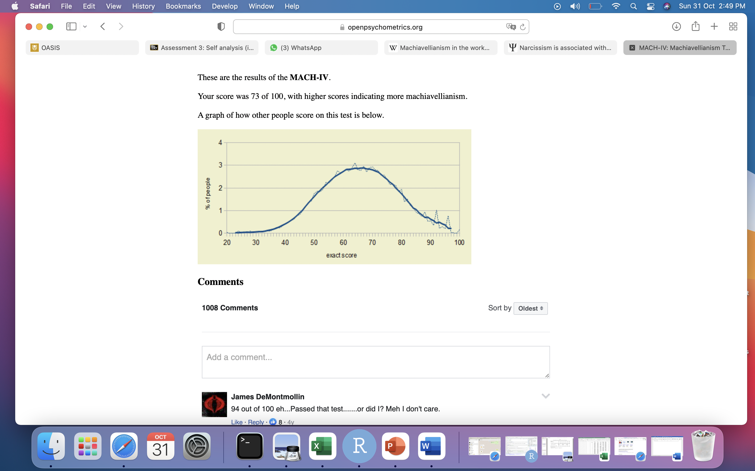

1. DISC assessment Test

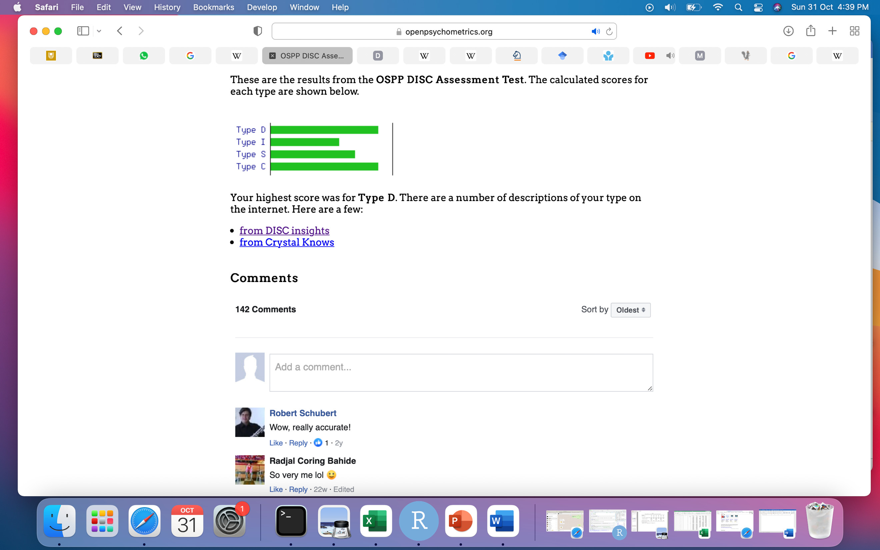

1. BIS/BAS Test

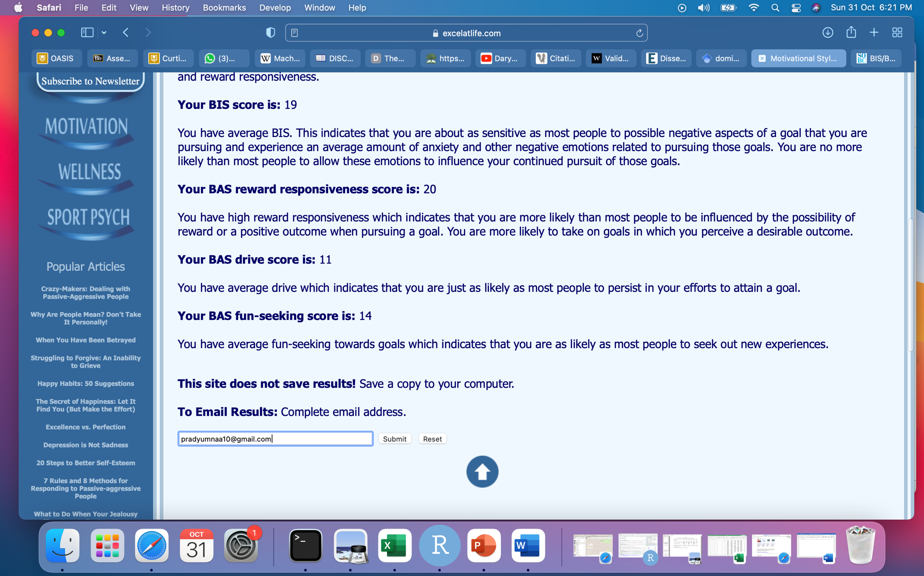

1. Communication Style Test

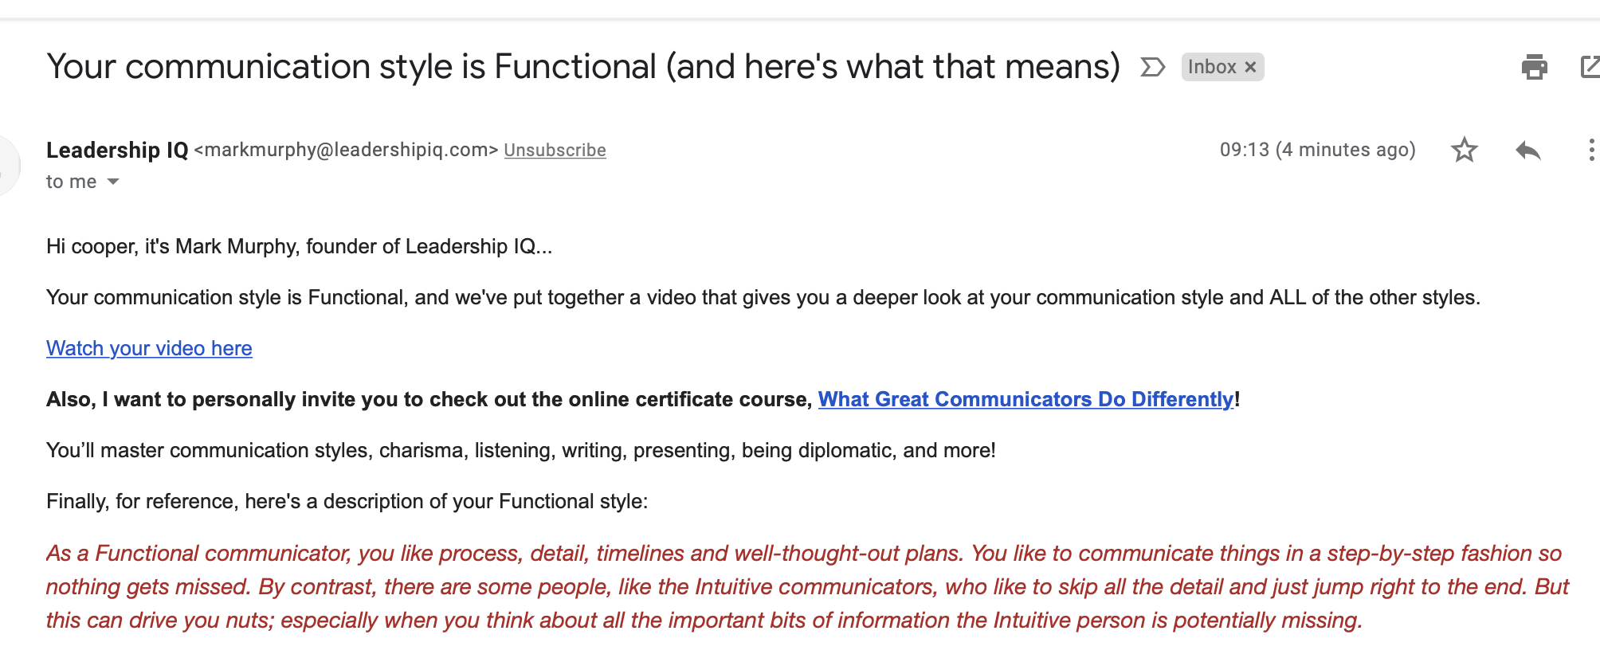

1. Tolerance of Ambiguity Test

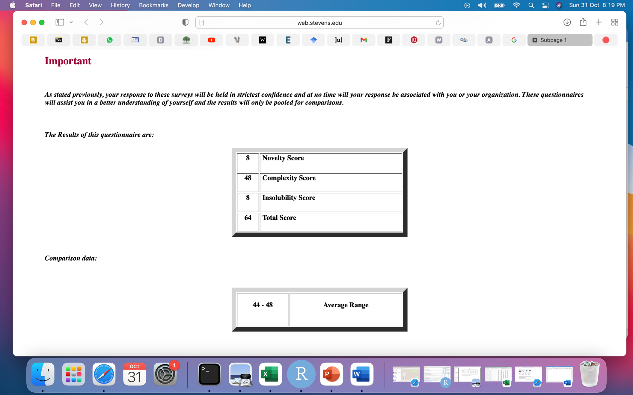

1. Leadership Skill Test

